class ----->  class ======> extends  ====> no multiple inheritance  
  
interface ----> class =====> Implements  
  
interface ---> interface ====> extends

Exceptions:   --> unexpected situations

2 categoried  
    - Checked  ---> compile time  
    - Unchecked  ---> Runtime time..

  pre defined exception classes  
    FileNotFound  
    ArrayIndexoutofBounds exception  
    NullPointer Exception  
    Arthematic Exception ...  
  
  user defined Exceptions  
  
try catch blocks  
try{

 }catch(Exception ex){

}catch(ArthematicException ex1{  
  
}  
finally{

sout(" ");  
}

Task 1:

public class Main {  
  public static void main(String[] args) {  
    int[] myNumbers = {1, 2, 3};  
    System.out.println(myNumbers[10]);  
  }  
}

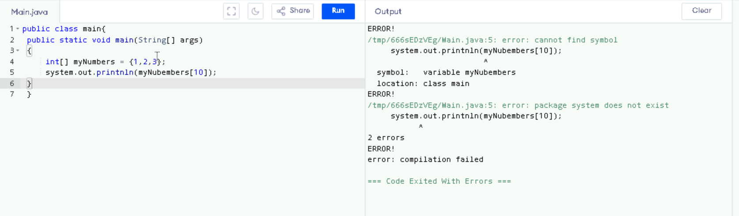

Task 2:

public class Main {  
  public static void main(String[] args) {  
    try {  
      int[] myNumbers = {1, 2, 3};  
      System.out.println(myNumbers[10]);  
    } catch (Exception e) {  
      System.out.println("Something went wrong.");  
    }  
  }  
}

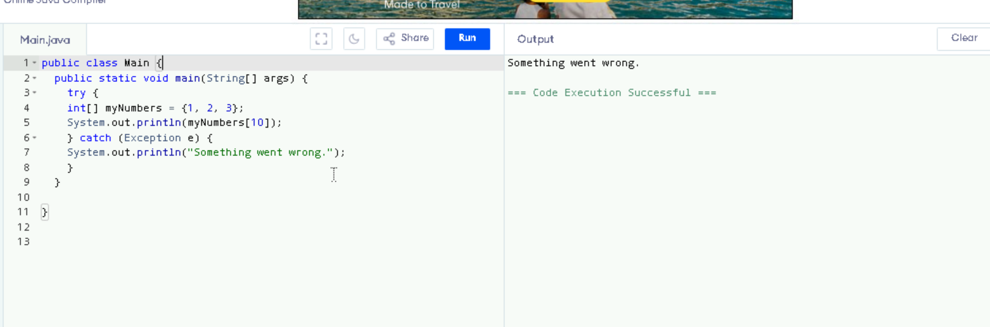

Task 3 :

 public class Main {  
  public static void main(String[] args) {  
    try {  
      int[] myNumbers = {1, 2, 3};  
      System.out.println(myNumbers[10]);  
    } catch (Exception e) {  
      System.out.println("Something went wrong.");  
    } finally {  
      System.out.println("I'm from finally block.");  
    }  
  }  
}

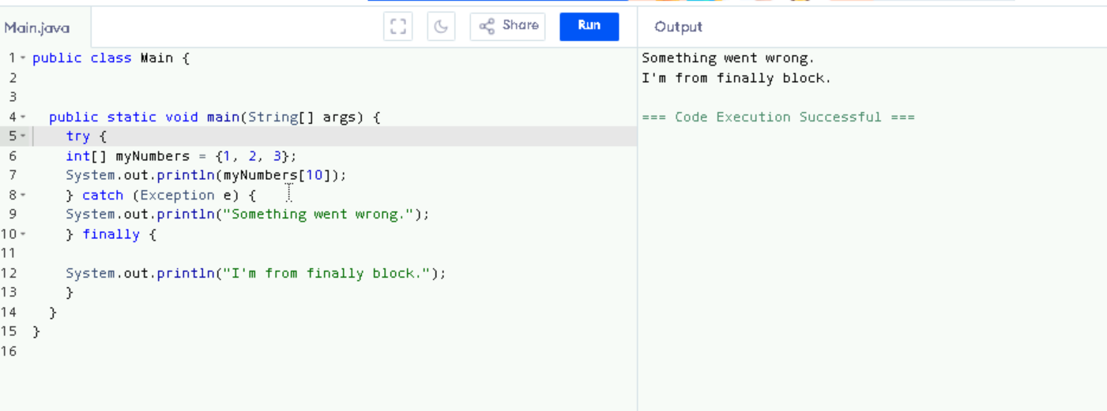

Task 4:

 from the above code from task 3 .. try accessing the 2 or the 3rd index and check the out..

assessing 2 index

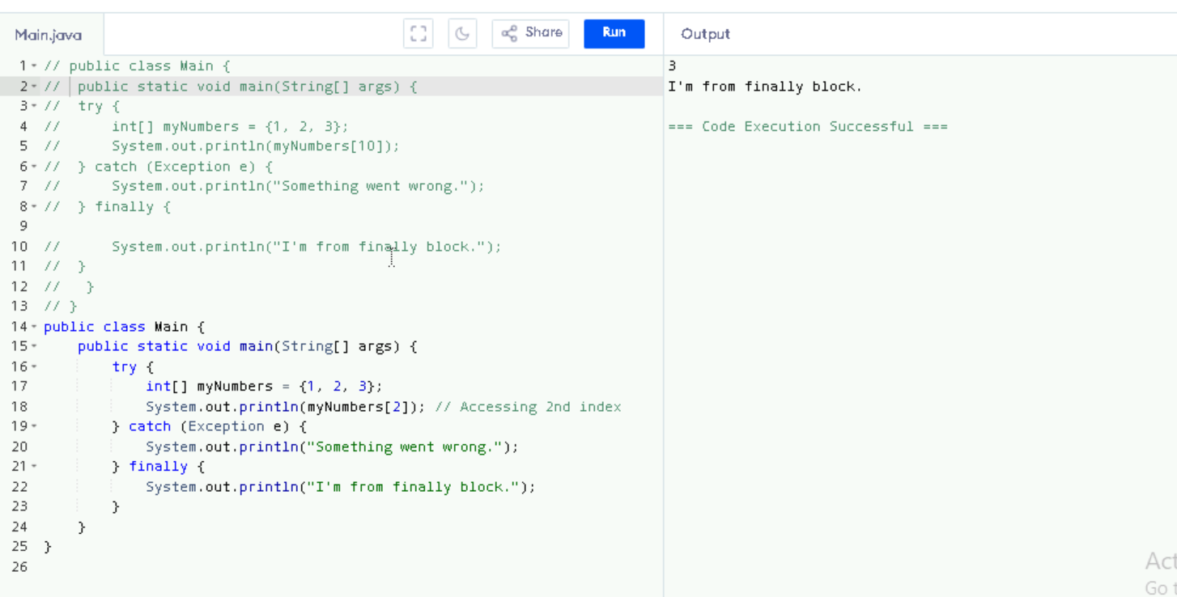

Assessing 3rs index

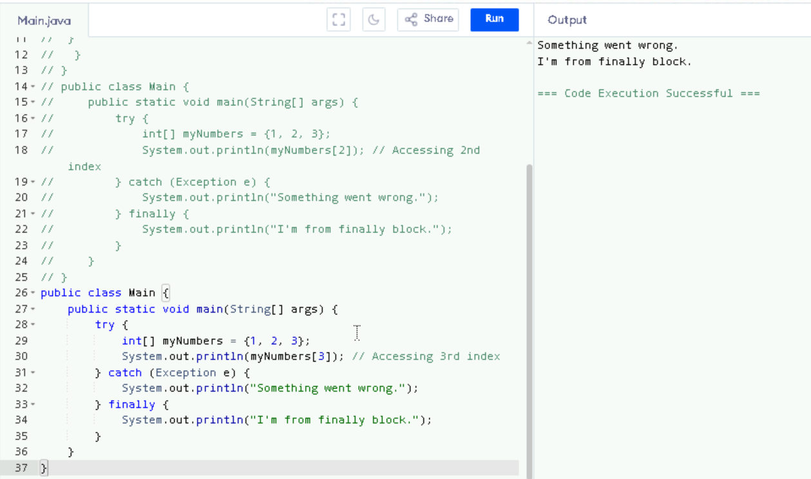

Task 5:

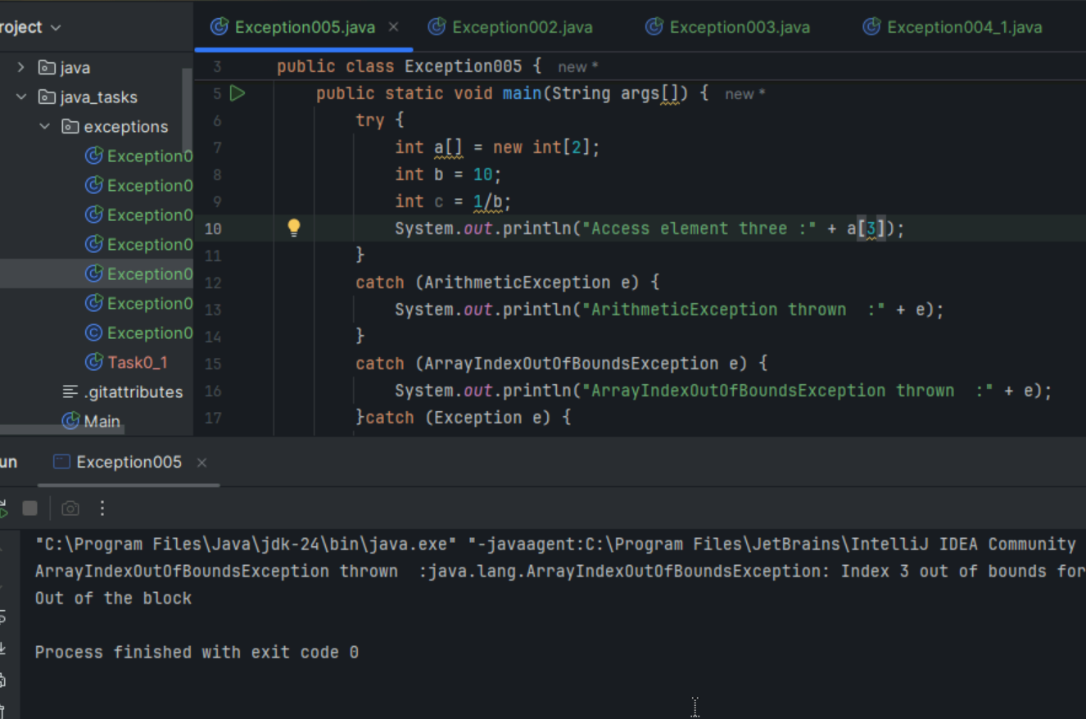

Task 6:

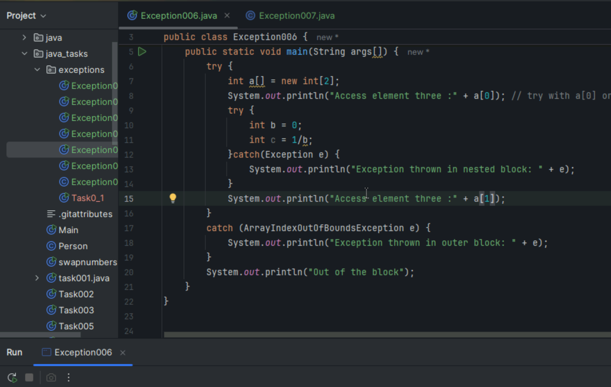

Task 7 :

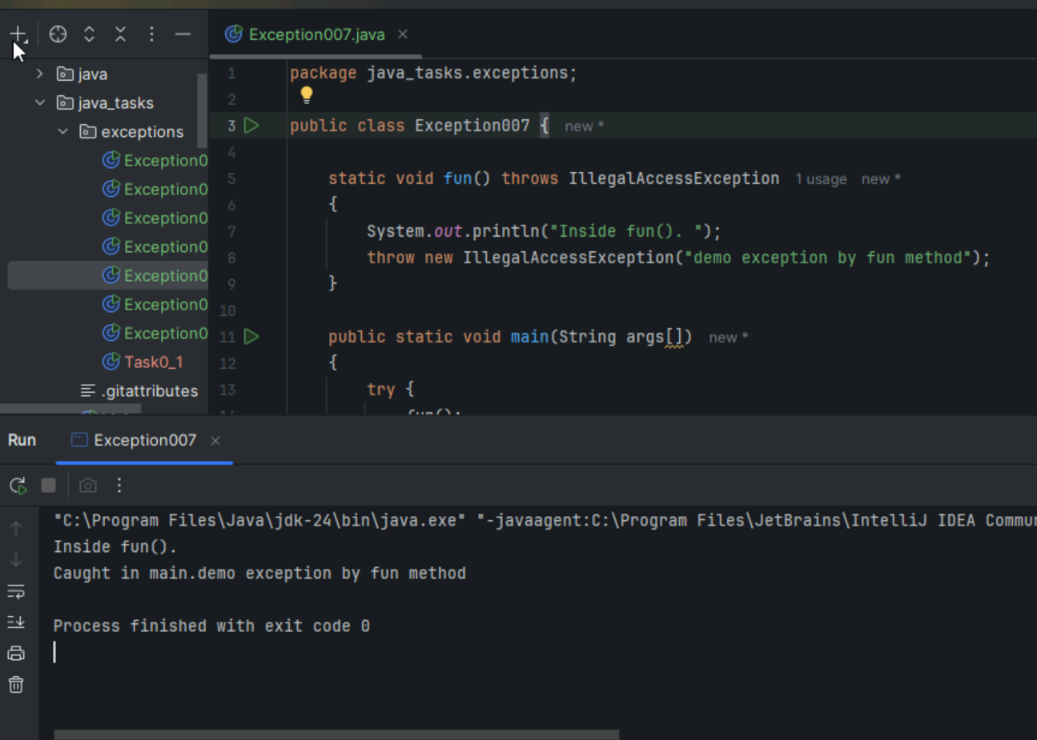

Task 8:

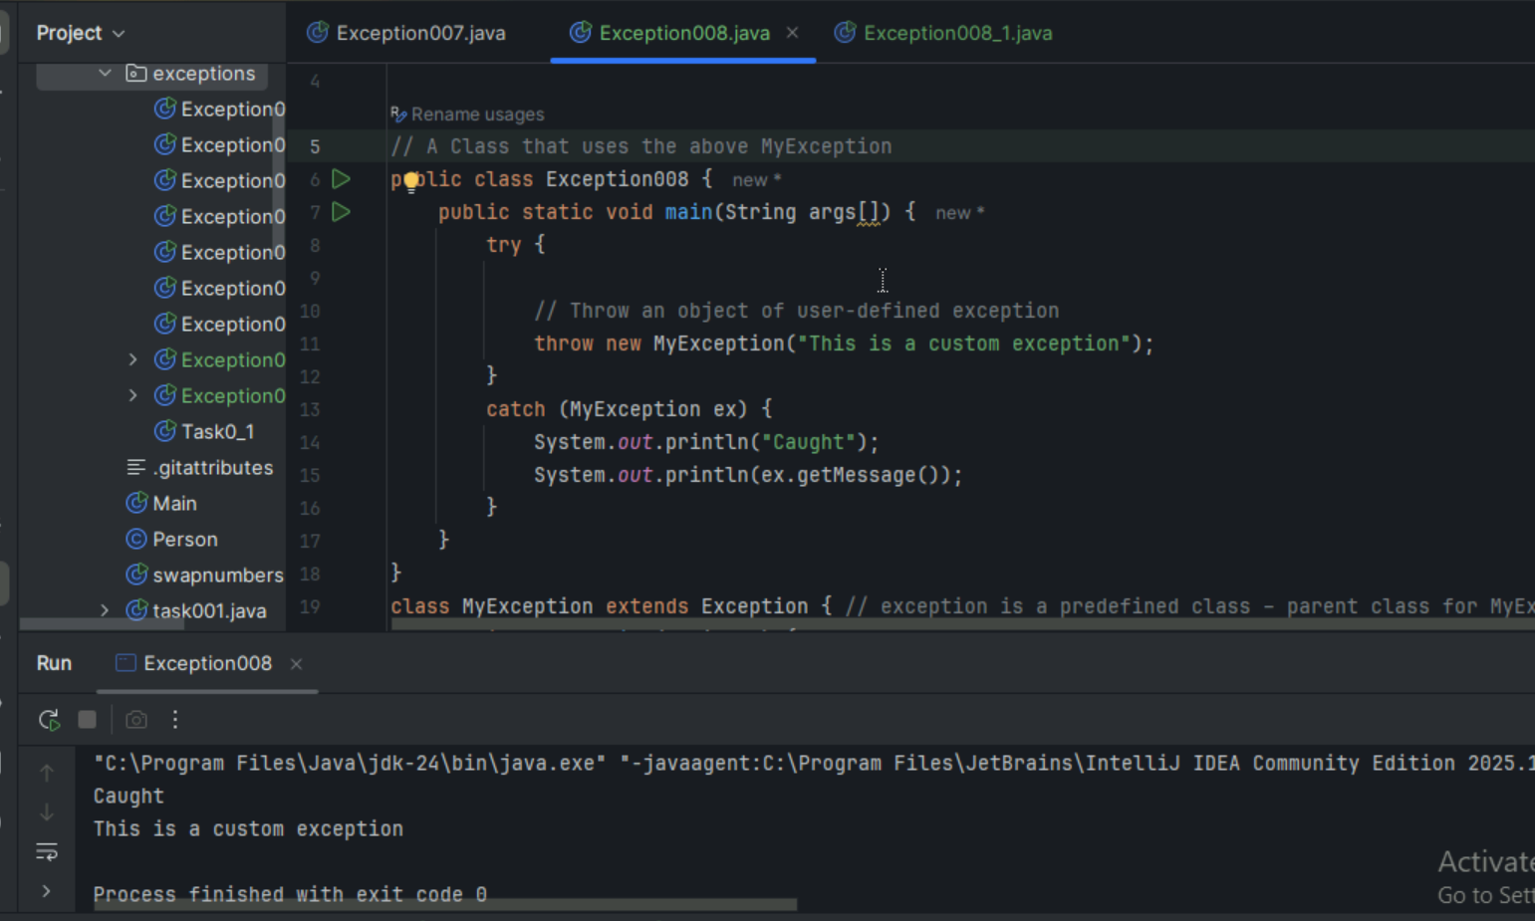

Task 9 :

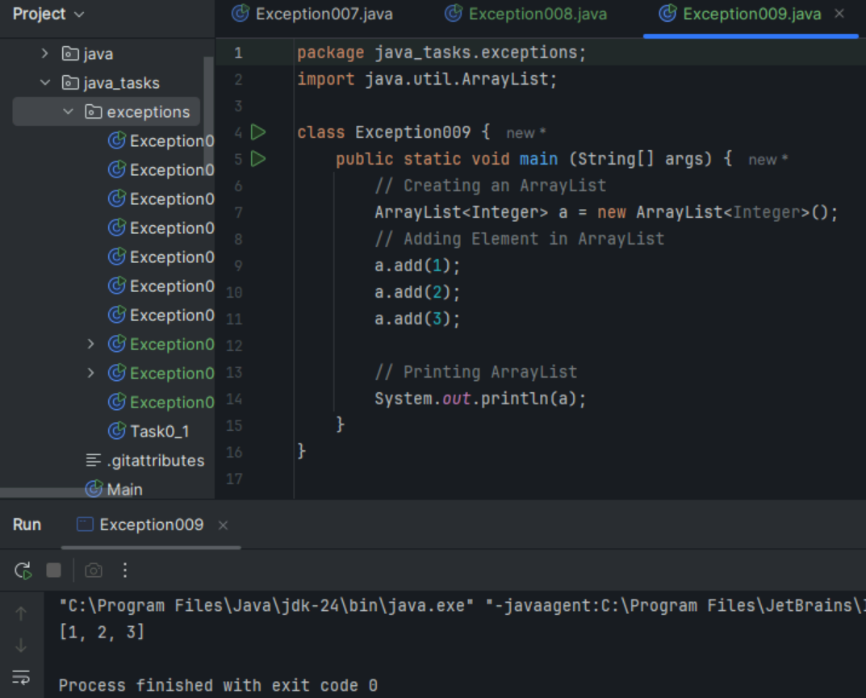

Task 10:

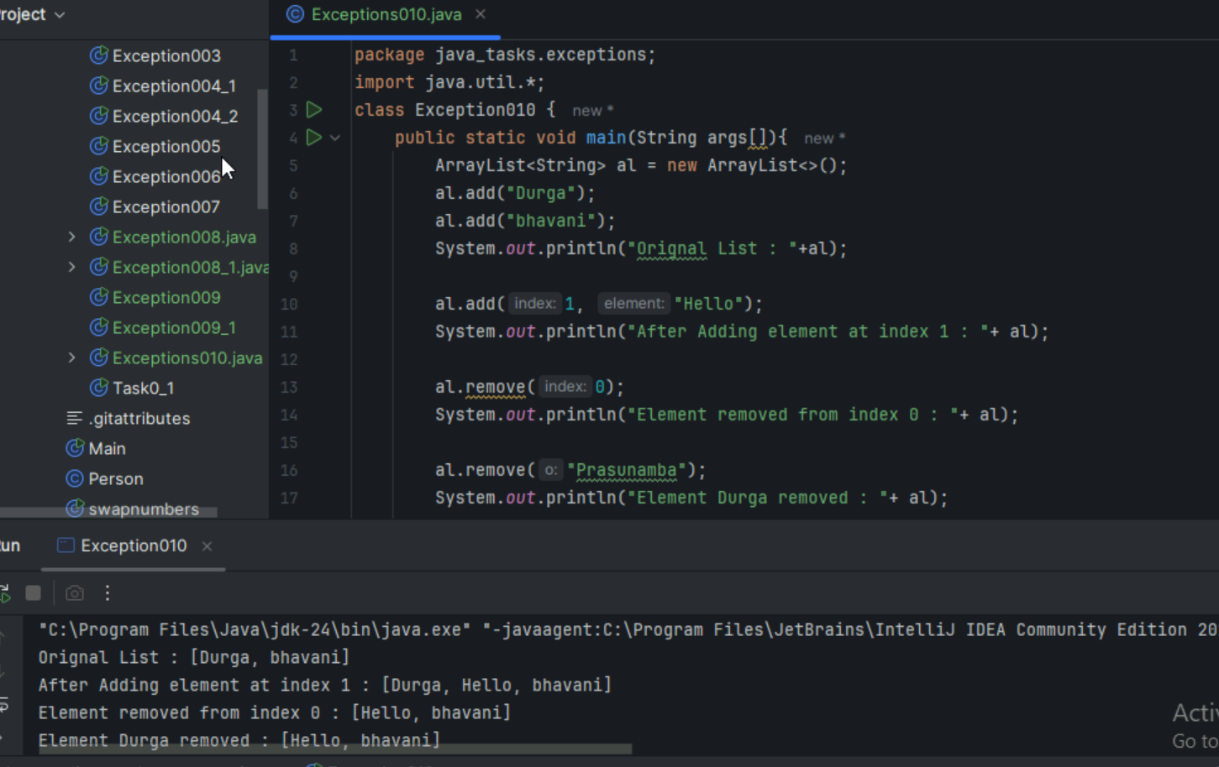

 Task 11:

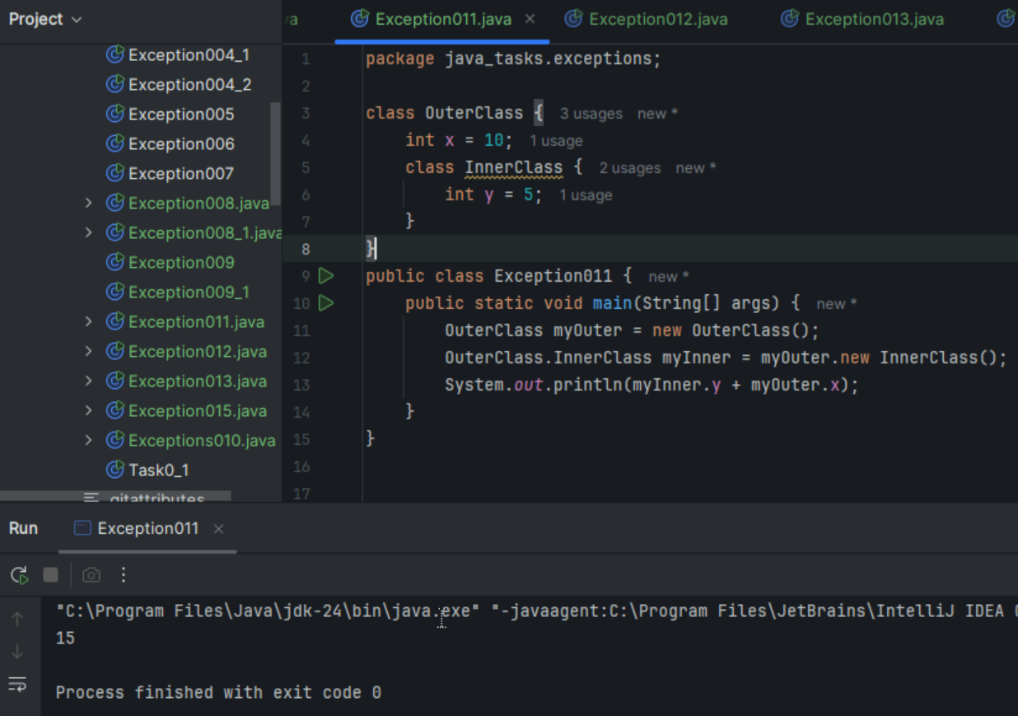

Task 12:

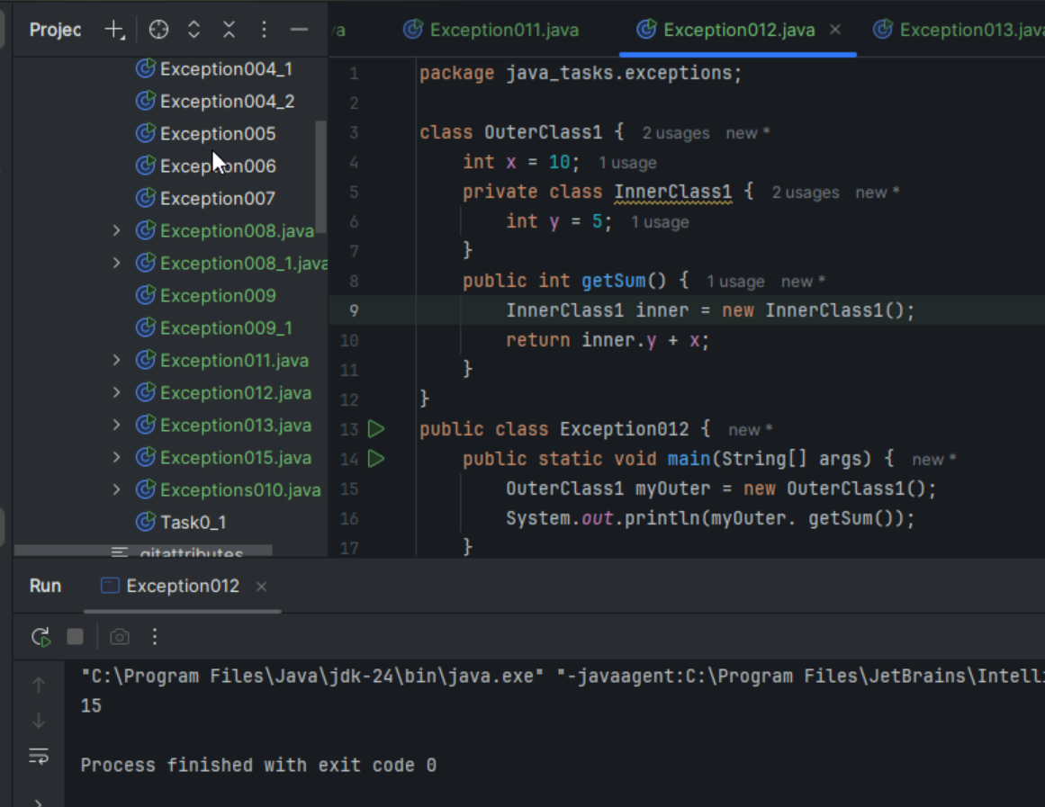

Task 13:

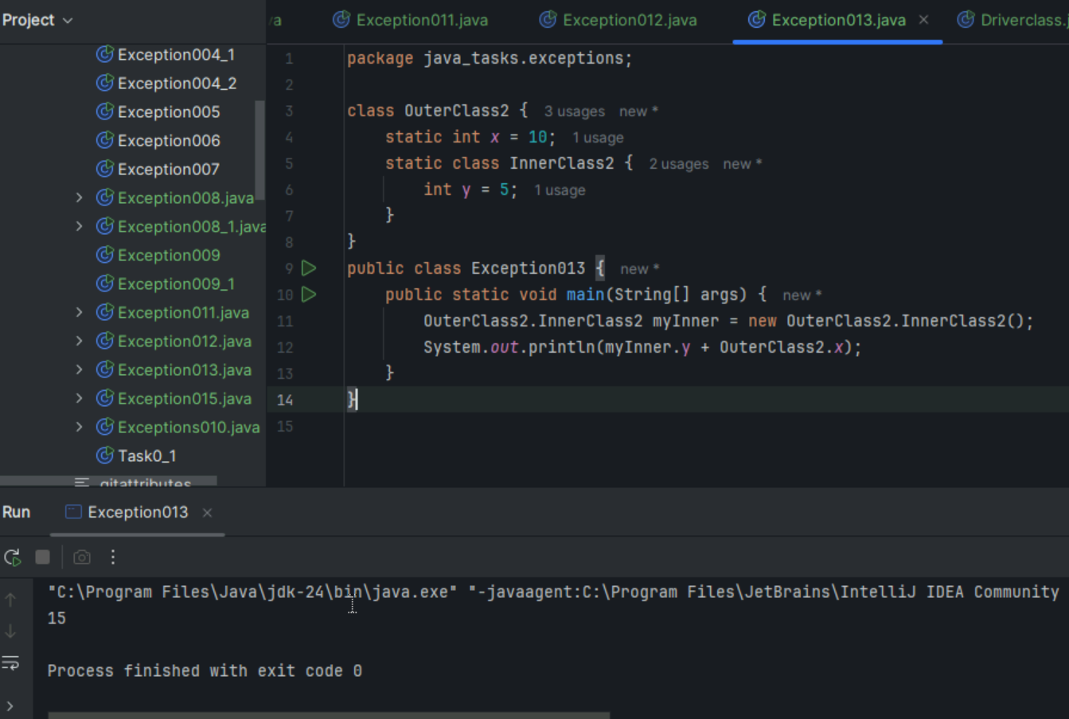

Task 14:

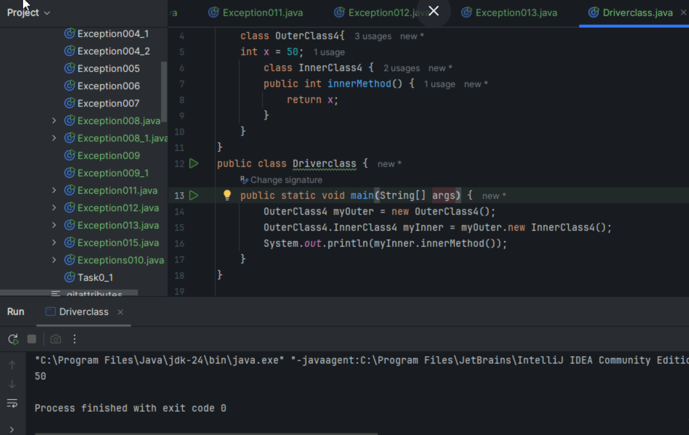

Task 15:

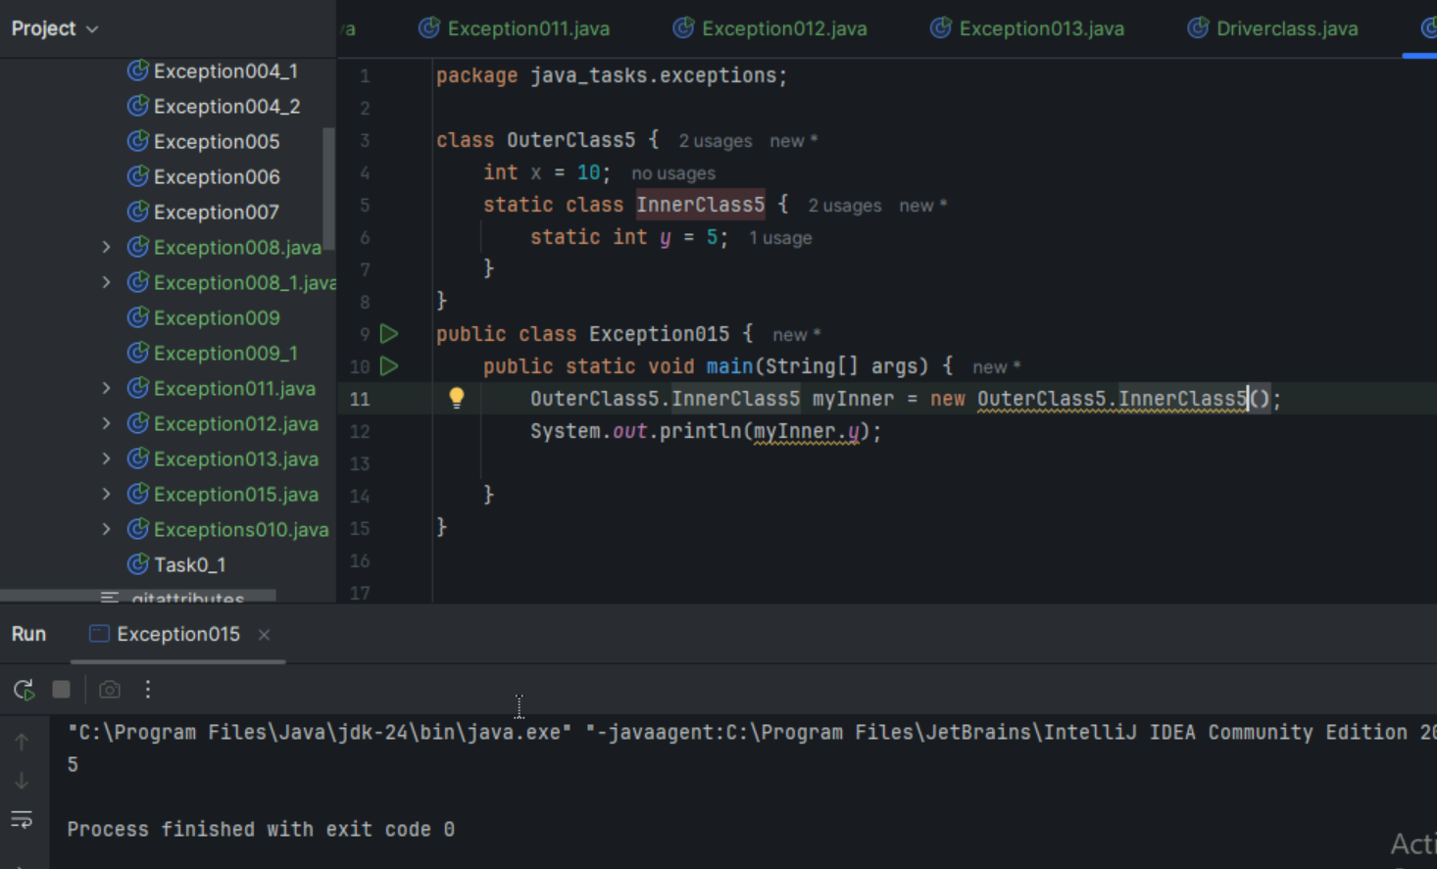

Task 16:

Inheritance, Abstraction concepts..

Classes customer/ person , employee, Manager  … 2 variables in each class

Driver class – display all the variables… toString();

Hint : use getter and setters..